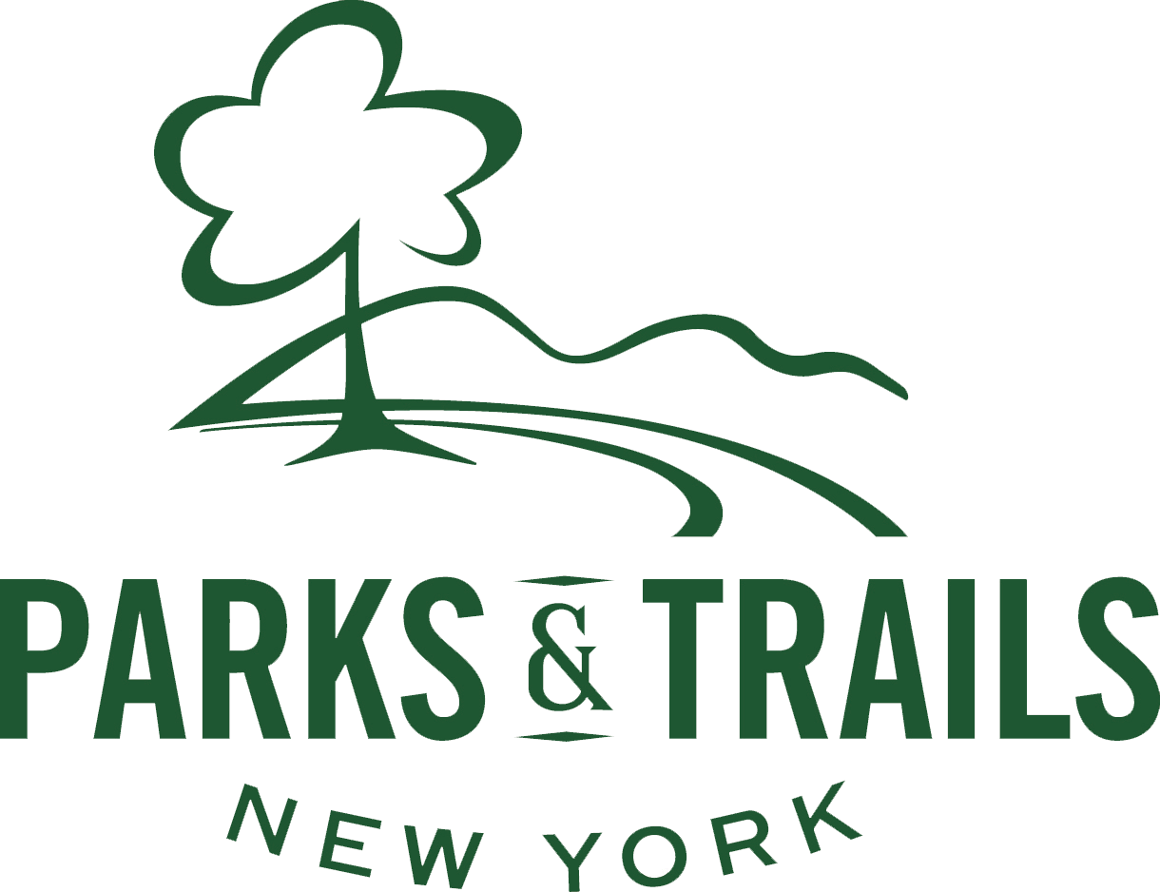

Paid Internship Opportunity with Statewide Environmental Organization

Arthur V. Savage Internship Program

The Arthur V. Savage Internship Program offers an opportunity for undergraduates, graduate students, and recent graduates to work in Albany, NY with the Parks & Trails New York (PTNY) staff to shape policies, organize grassroots constituents and provide stewardship for parks, public lands, and other outdoor recreational facilities. The program provides interns with valuable, first-hand professional experience in the environmental field.

Specific Responsibilities: Assist with a variety of program, research, communications, and engagement tasks related to protecting, promoting and enhancing New York’s parks and public lands. Projects include:

- Events – assist in organizing and promoting our regional conferences for park groups, Friends-to-Friends Workshop series, Park Advocacy Day, I Love My Park Day, and local events across the state.
- Communications – assist with print and e-publications, website content and production, social media, and marketing strategies, including direct and in-person engagement, as needed.
- Advocacy & Research – assist with PTNY’s statewide advocacy efforts for parks and public land funding, communicate with elected official’s staff, and conduct surveys and research related to the best practices for grassroots organizations and the impact of our work on local communities.

Qualifications/Skills: Well organized, excellent oral and written communications skills, ability to work on multiple projects, strategic thinker, experience with Microsoft Office, web-based tools and social media. Demonstrated interest/experience in environmental stewardship, conservation, parks, and/or community engagement.

Hours: Part-time, approximately 20 hours/week, beginning in August or September and running through December 2022 with a good probability of continuing into Spring 2023. Hours are flexible in terms of days and times but must be within regular work week hours (M-F, 8-5).

Work Environment: Interns work closely with staff in a friendly, hard-working, casual atmosphere. Work will be primarily virtual, in combination with some in-person hours.

Compensation: $15 per hour, may be used for college internship requirements.

To Apply: Please send a cover letter, resume, and references (including a former employer or supervisor of volunteer work) by June 30, 2022 to wcote@ptny.org with the subject line “ASI Internship.” Please include a proposed work schedule in your cover letter.

Parks & Trails New York, 33 Elk Street, Albany, NY 12207, www.ptny.org, 518-434-1583

PTNY is an Equal Opportunity Employer that actively seeks a diverse pool of candidates for this position. We encourage all qualified candidates to apply, and do not discriminate in our hiring on the basis of race, ethnicity, national origin, age, gender, religion, sexual orientation, or differing ability.
Arthur V. Savage (1926-2012) was a distinguished lawyer-conservationist, with a particular devotion to the preservation of open spaces and public parks in New York State. During the last half of the 20th century, Arthur co-founded or led a large number of nonprofit organizations that shape environmental laws, protect natural resources, and educate the public about conservation values. He was a 20-year member of the PTNY Board of Directors. To honor the life and legacy of one of New York State's most influential environmentalists, PTNY is proud to offer the Arthur V. Savage Internship Program.

