ENV & CLIMATE JUSTICE
POLS 3240E-20 (1871): Virtual/Asynchronous
Summer II: Jul 11 - Aug 12, 2022
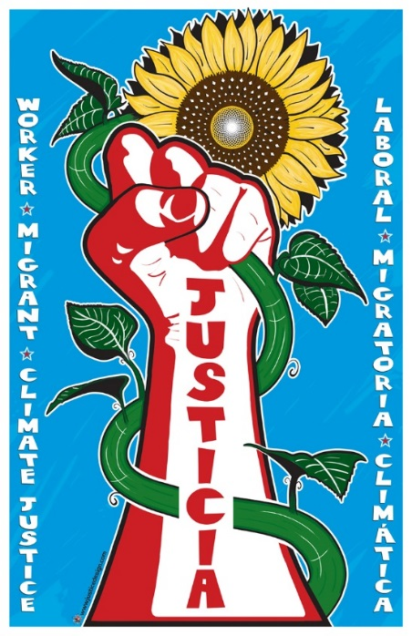

Counts toward UConn Environmental Literacy requirements and toward a Major/Minor in Environmental Studies; Human Rights; Urban Studies; Political Science; Relevant to Public Policy; Economics. Other Majors are very welcome to join this interdisciplinary course.

This course will introduce you to the major concepts and debates related to the unequal effects of climate change, including those of the ongoing efforts to combat climate change. We use ‘climate justice’ as a lens to comprehend and analyze the nexus between climate change on the one hand and social, economic, and political inequalities on the other hand. We will use concepts from political science, environmental studies, and human rights to accomplish these goals. Exciting course material includes audio-visual resources, popular press reports, and research articles to engage with questions of justice climate action, urban resilience, food sovereignty, and renewable energy transition.

Questions? Email Professor Kashwan prakash.kashwan@uconn.edu

